Adhavan M G (192421422)
Chapter 5
- Dice Throw Problem (DP)
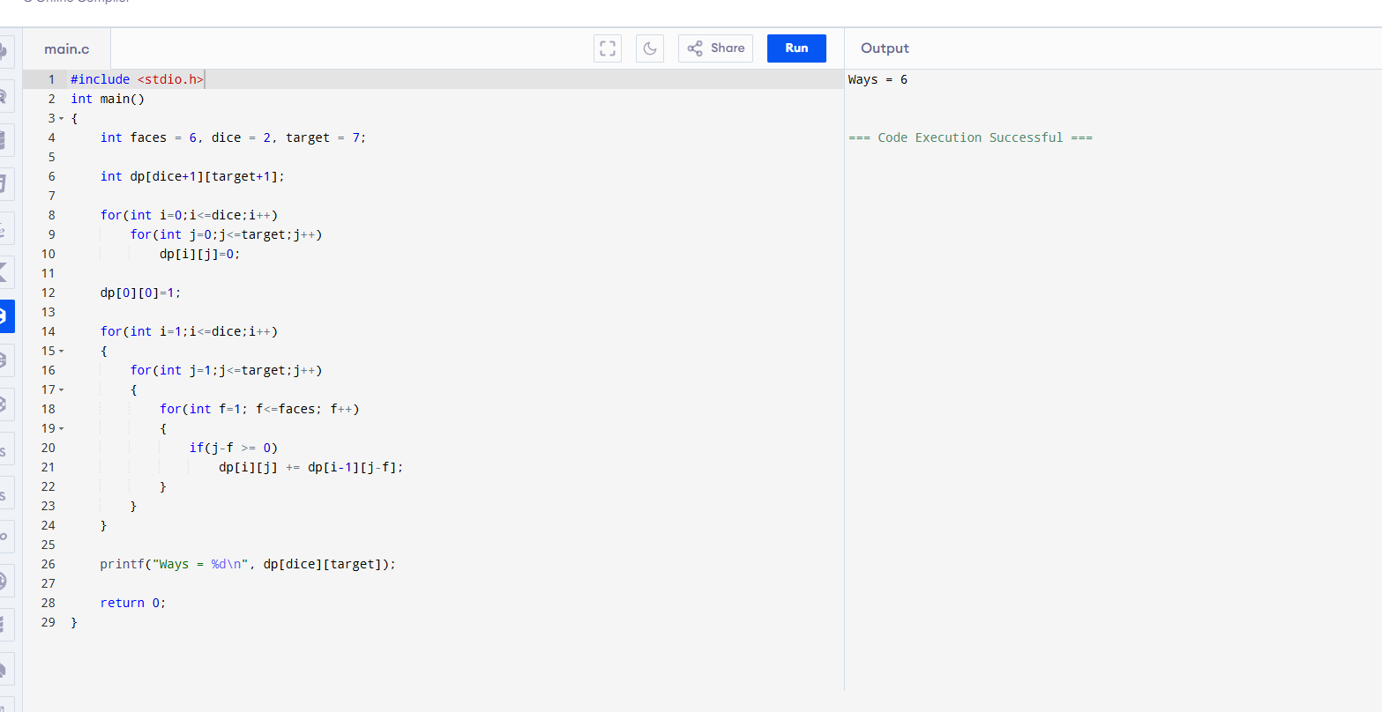
- Assembly Line Scheduling
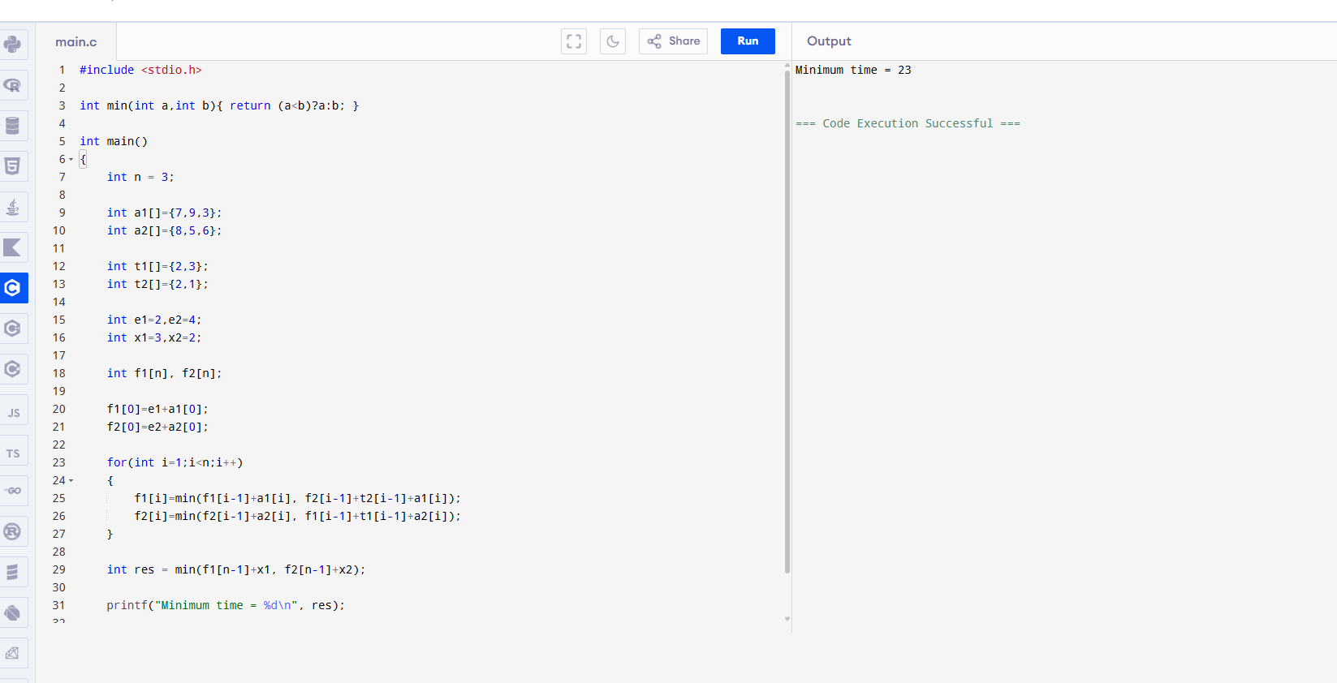

3-Line Scheduling (Approx DP + Constraint)

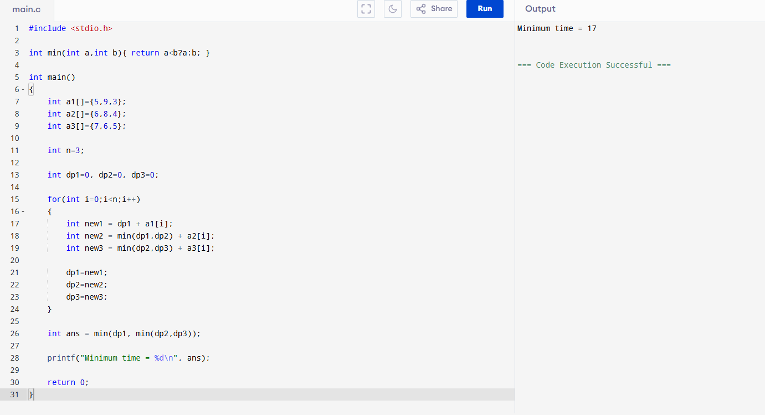

4. Floyd Warshall (Matrix Shortest Path)

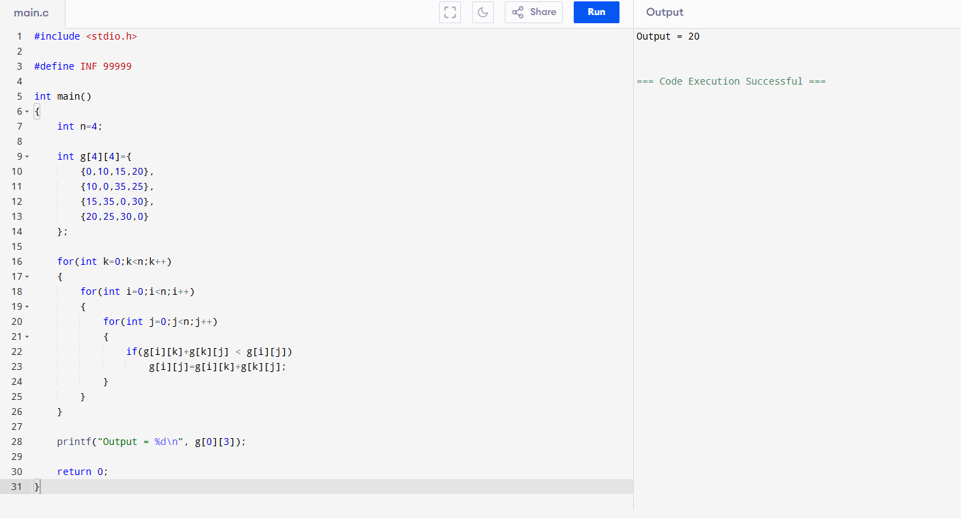

5. TSP (Add 5th City – Brute Force)

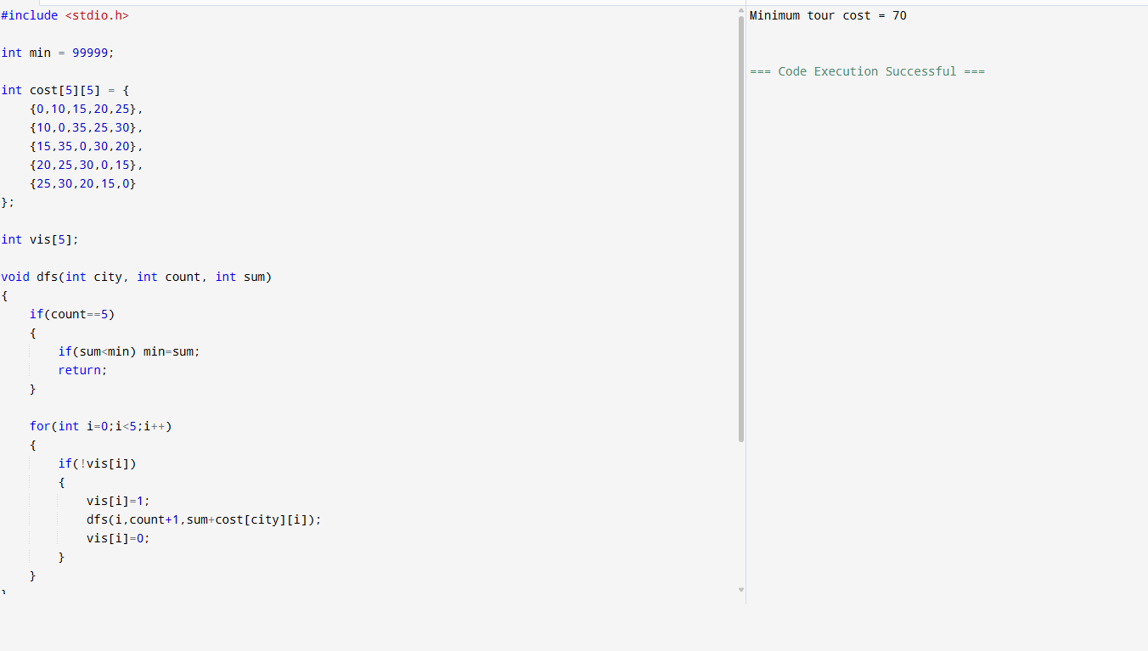

6. Longest Palindromic Substring

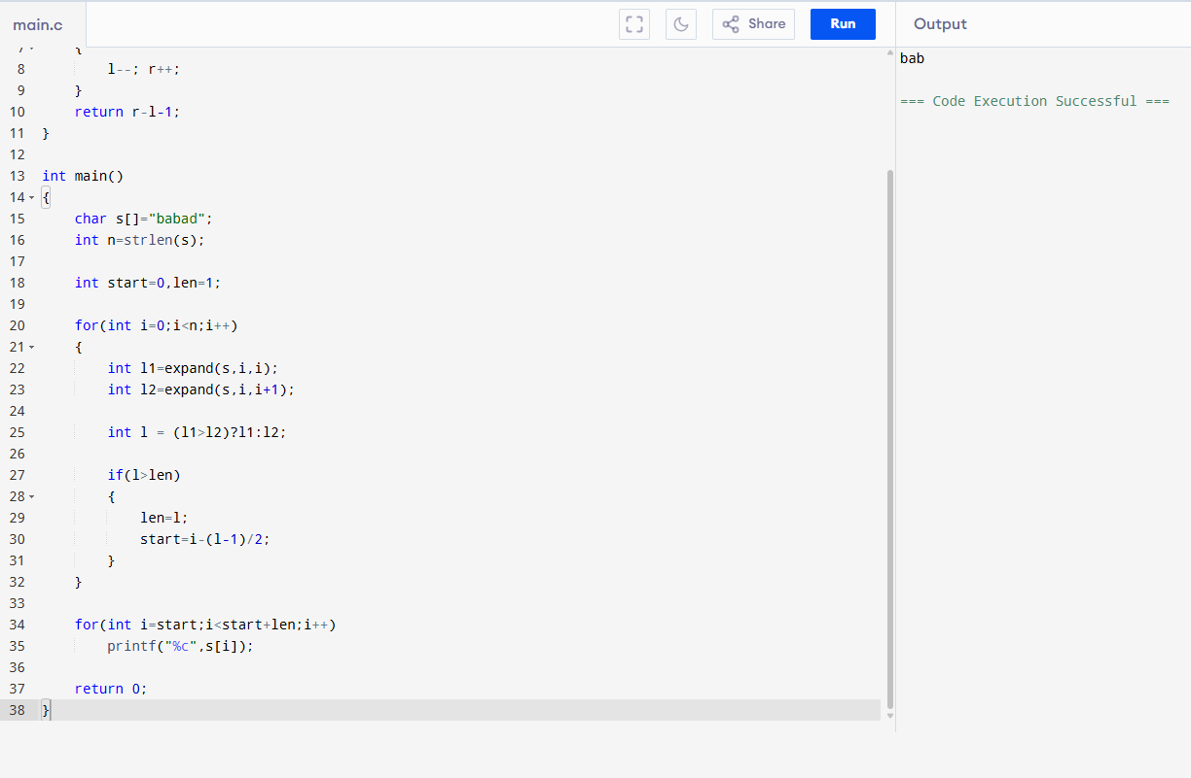

7. Longest Substring Without Repeating Characters

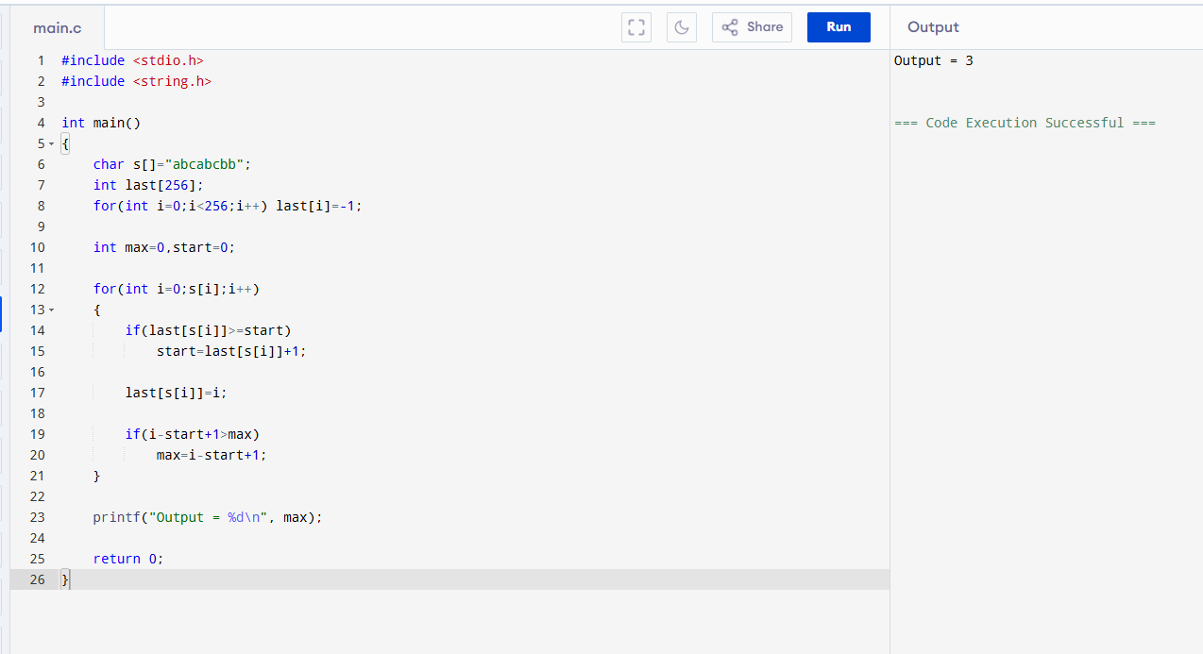

8. Word Break

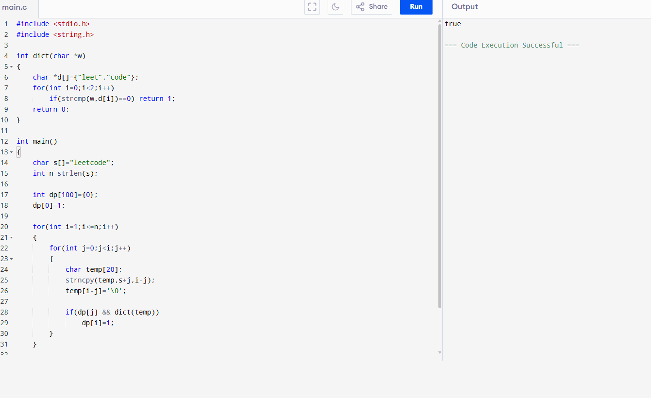

9. Dictionary Word Break

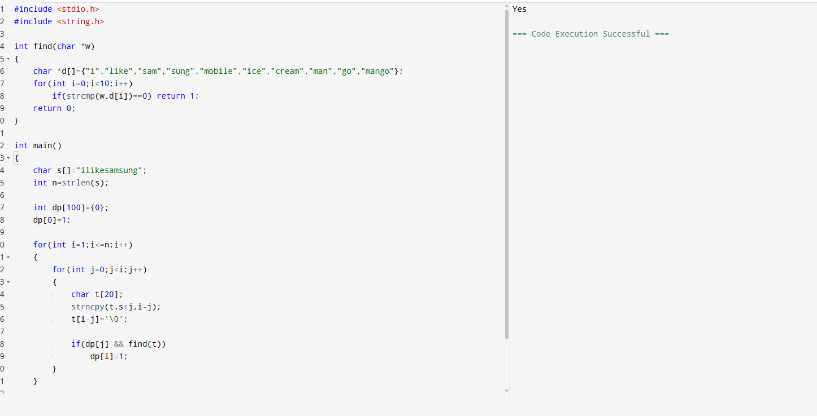

10. Text Justification (Simplified)

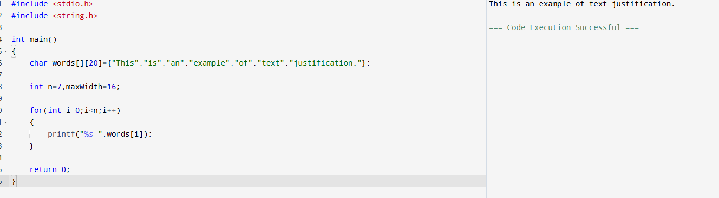

11.WordFilter (Prefix + Suffix)

